
Every child is a learner and can achieve

POLICY TITLE:
Behaviour Policy
COMPILED BY:  Pip Greetham | DATE APPROVED:  October 2025 | DATE TO BE REVIEWED:  October 2026

Introduction

At Hoyle Court Primary School, we are committed to enabling all children to be safe and able to access learning in school.

Hoyle Court prides itself on being an inclusive school that meets the needs of a range of children. We are committed to establishing a high standard of behaviour throughout the school. The staff at Hoyle Court Primary School see this policy as a positive, planned set of strategies to manage and be effective in creating a warm and caring learning environment.

All staff, children, governors and parents recognise that we have the right to learn in an orderly community in which effective learning can take place. Our three key rules are:
“READY, RESPECTFUL & SAFE”.
We have discussed with our children what these words mean, how they can use these words to help them in school and what their behaviour may look like when they are ready, respectful and safe. This is what they think:
- We are READY to learn – we arrive at school on time, we have our equipment ready and we show that we are listening
- We are RESPECTFUL – we are respectful of other peoples’ values and beliefs, we listen when others speak and we respect the property of our friends and the school.
- We are SAFE – we move around school in a safe manner, we follow instructions to keep ourselves and others safe.
Aims

- We will be ready, respectful and safe.
- We will promote wellbeing by providing a safe, caring and supportive environment for every member of our school community.
- We will create an atmosphere where children can become well rounded, self- disciplined, respectful, moral and caring.
- We will praise and reward positive attitudes to behaviour.
- We will support children to make good choices and put suitable sanctions in, if poor choices are made.

At Hoyle Court our emphasis is on positive behaviour and reinforcing this, rather than focusing on negatives. These rewards are aimed to motivate and help children to make the right choices. It is essential that staff are consistent when enforcing the school rules with high expectations and will challenge unacceptable behaviour in a solution focused response.
Rewards

When managing behaviour, the primary focus should always be on positive reinforcement. Rewards need to be frequent, consistent and sure to happen in order to be effective. At all times, adults should be looking for opportunities to reinforce appropriate behaviour – ‘Catch them doing something good!’. These procedures are based on the basic principle of: Public Praise; Private Disappointment (consider an approximate ratio of 3 : 1). The rewards for such behaviour are intrinsic and we recognise that feeling good about something you have done is a very significant reward.

We reinforce positive behaviour in a range of ways, these include: regular and precise verbal praise, dojos, dojo of the week, champion learner of the week, stickers, headteachers awards, phone calls home

Anti-bullying statement
At Hoyle Court Primary School we are committed to providing an environment where every person has the right to be themselves, feel included and be able to learn in a safe and happy environment. In line with being a school of sanctuary, everyone at our school is equal and treats each other with respect and kindness.
Bullying is when a person is hurtful or unkind to someone else, on purpose and more than once. Bullying can be done by one person or by a group of people. At Hoyle Court Primary we define bullying as Several Times On Purpose (STOP.) Here we pride ourselves on being an inclusive and kind school. We feel prevention is better than a cure, so we are vigilant for signs of bullying and always take any reports of bullying seriously. All members of the school community have a responsibility to challenge bullying if it occurs. All staff members at the school are made aware of the procedures that they should follow if an incidence of bullying is brought to their attention.
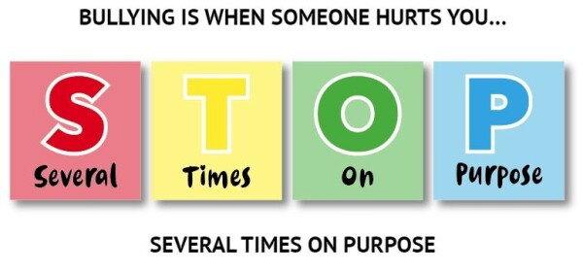
Peer-on-peer abuse
Peer on peer abuse is sexual, emotional or physical abuse that happens between children of a similar age or stage of development. It can happen between any number of children and can affect any age group (Department for Education (DfE), 2018).
At Hoyle Court Primary School, we recognise that, although it is rare, children are vulnerable to and capable of abusing their peers. We take such abuse as seriously as abuse perpetrated by an adult. This includes verbal as well as physical abuse. The governors, senior leadership team and all staff at the school are committed to the prevention, early identification and appropriate management of peer-on-peer abuse both within and beyond the school. The designated safeguarding lead will take a leading role using their professional judgement and be supported by other agencies such as social care or the police as required. It is important to deal with a situation of peer abuse immediately and sensitively. It is necessary to gather the information as soon as possible to ascertain what has happened and if any other students are aware or involved. It is equally important to deal with it sensitively and think about the language used and the impact of that language on both the children and the parents when they become involved.

A Restorative Approach
At Hoyle Court Primary School we believe that setting high standards for behaviour is an integral part of having positive attitudes to learning and raising attainment. We pride ourselves on being a restorative school. We feel our restorative approach (RA) is imperative to whom we are, and that this permeates all areas of our school life. This approach is at the foremost of our community members (pupils, staff, parents, carers, governors, visitors etc.) Being ‘Restorative’ focuses on building positive relationships based on respect and fairness. In turn this creates a community that is supportive, accountable and respectful. We believe that every individual is responsible for their own behaviour.
Incidences of negative behaviour are dealt with in a fair, respectful and appropriate way, with the key focus on individuals taking responsibility for their behaviour, repairing any harm done, rebuilding and restoring relationships.

The Restorative Questions:

What happened? Drawing out each person’s story one at a time, starting with the person who has caused the harm. The aim is not necessarily to come to a definitive conclusion on what has happened, but for each person to have their point of view listened to.
What do you think and feel about that? What each person was thinking and feeling at the time, before and since.
Who has been affected and how? Who has been harmed/affected and how? Older children are encouraged to think about the wider implications of who has been affected e.g. the school community and families.
What are the needs of those involved? What those affected need to feel better, move on, repair harm and rebuild relationships.
What do you think needs to happen next/to make things right with each other and with the school community? How do those people agree and negotiate meeting the needs identified above and what support might they need to do this? Staff support pupils in this process but try to ensure the pupils form their own agreement when possible.

This approach encourages those involved to identify ways in which a relationship can be repaired or how they can move forward. By giving pupils this responsibility we are supporting them in developing their own strategies for avoiding and resolving conflict. All staff working within our school use active listening skills when dealing with a conflict. This is shown below:

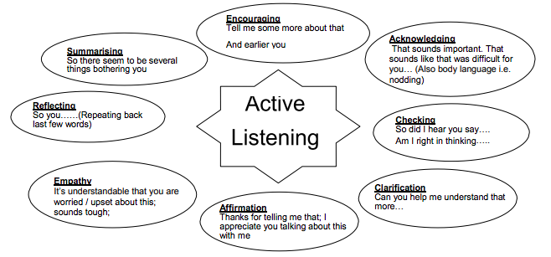
Sanctions
- All sanctions at school are underpinned by the restorative approach and restorative conversations will be held across all stages.
- All sanctions have been developed in consultation with the pupils at school and the 4 steps are displayed in each classroom across the school.
- Sanctions need to be consistent and followed up in order to be effective.
- Sanctions are to be used in the classroom and throughout school.
- If a pupil reaches step 3 or step 4 then parents will be contacted.
- In rare circumstances, reasonable force may be used to prevent pupils from committing an offence, injuring themselves or others, or damaging property, and to maintain good order and discipline in the classrooms.
At Hoyle Court Primary School, we recognise that all children are unique individuals and therefore we are flexible in the manner in which we address any incidences of negative behaviours. This is dependent on the age / stage / understanding of each child. Depending on age and particular circumstances, different behaviours may warrant one or a combination of consequences, all of which are decided with restoration at the forefront. Adults should use their professional judgement when supporting a child to restore the issue and reasonable adjustments can be made, particularly with vulnerable children or children with SEND.
Steps | Behaviours | What might happen? | Visual support
Steps to success | - Listening to adults  - Being polite  - Ready to learn  - Trying your best  - Hands up  - Hoyle Court values – Respect, Responsibility, Resilience, Teamwork and Kindness | - Praise  - Dojo points  - Champion learner  - Champion dojo  - Feeling proud  - Postcards home  - Phone call home |         
Step 1 | - Not on task or avoiding work  - Disrupting others in the classroom  - Not following instructions | - Teacher will give pupil a reminder  - Teacher will give a pupil a warning that it will move to step 2 |   
Step 2 | - Repeatedly disrupting others  - Continuing any of the Step 1 behaviours  - Displaying disrespectful behaviours | - Time out in an area of the classroom or another classroom if necessary – 10 minutes |     10
Step 3 | - Swearing  - Being rude or shouting  - Constant disruption to people or learning time  - Continuing Step 2 behaviours  - Leaving the classroom without asking permission. | - Pupils to miss 15 minutes of break |     15
Step 4 | - Continuation of Step 3 behaviours  - Leaving school grounds  - Physically hurting someone on purpose  - Immediate danger to themselves or others  - Significant damage to property  - Bullying  - Racism | - Member of Senior Leadership Team to be contacted.  - Child to spend time in SLT office (break and lunch)  - Parents to be contacted the same day.  - Internal exclusion  - External exclusion | 

Internal exclusion can be used to exclude pupils to enable pupils a longer amount of time to reflect on their behaviours. This decision is made by a member of the Senior Leadership Team at stage 4 and may vary in where, when and for how long.
External exclusion for serious incidents. This is likely to be a behaviour that has caused significant harm or damage. The school reserves the right to exclude any pupil for a fixed term without using the above consequence process.
‘Behaviour for Learning’ in every classroom

What is ‘Behaviour for Learning’?

Whilst it may look different in each year group, ‘behaviour for learning’ develops the key skills children need to master to become successful learners. Our 6 key behaviours build on our growth mindset ethos and show children how they can become more confident learners, who always aspire to do their best. These are also tied in to our house point system, with each pupil proudly representing one of the behaviours for learning.

Why is Behaviour for Learning so important?

To be a successful learner, each child needs to develop key aptitudes that will enable them to access all their learning to the fullest extent. Our 6 key behaviours will develop skills and attitudes to learning that will put our children in good stead for the challenges they will meet throughout their lives. We are helping to build successful futures for all our children by showing them how to be highly motivated learners.

The six key behaviours for learning at Hoyle Court Primary are represented by six wonderful animals:

The Wolf - Independence
The Ant - Collaboration
The Eagle – Challenge
Lion – Pride
Tortoise - Determination
Monkey - Curiosity

Each animal comes with their own story to illustrate their behaviour.
Each behaviour comes with a series of ‘I can…’ statements to help every child master them.
Children will be specifically rewarded using a range of intrinsic and extrinsic motivation. These include but are not exclusive to: sense of pride, dojo points, certificates during celebrations assembly, postcards home, being placed on the proud patch, messages/phone calls home. We love to celebrate the children who are showing awesome learning behaviours.

Appendix A - Behaviour for Learning statements at Hoyle Court Primary School
Independence  (Wolf) | Collaboration  (Ant) | Challenge  (Eagle) | Pride  (Lion) | Determination  (Tortoise) | Curiosity  (Monkey)
 |  | 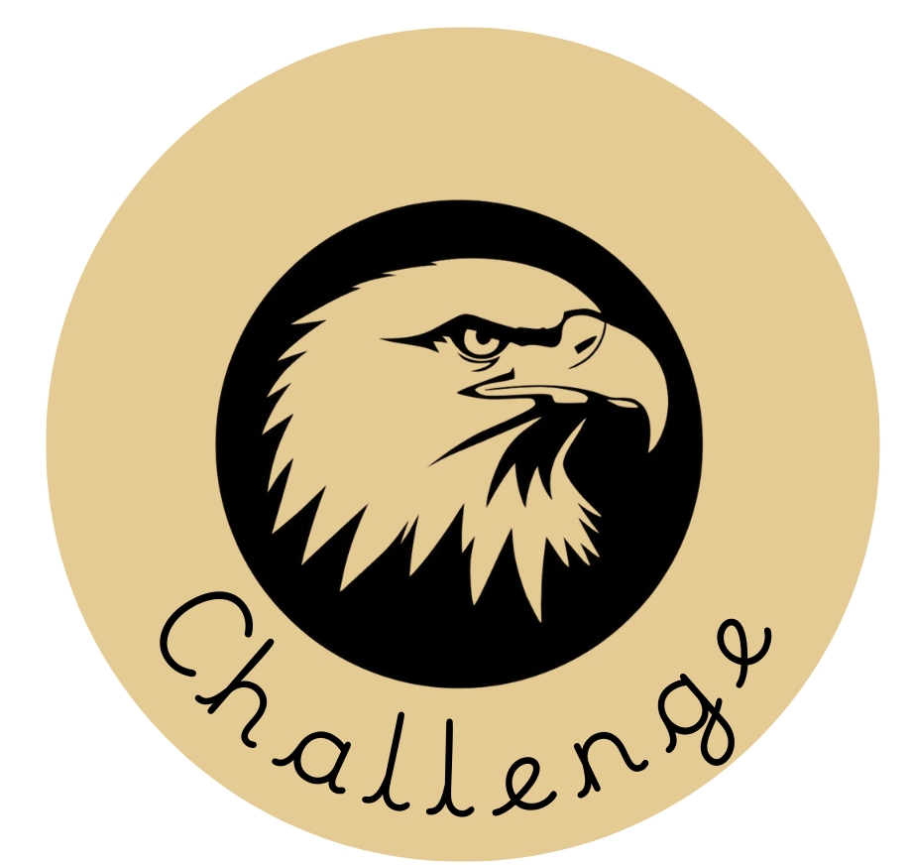 |  | 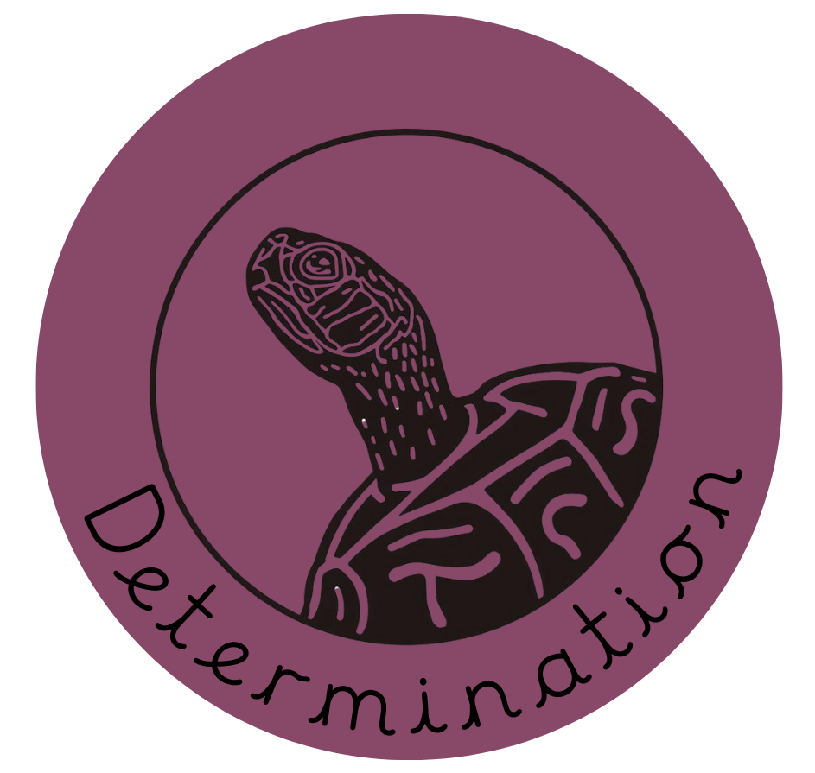 | 
I can settle into learning quickly  I can remain focussed  I can use my initiative  I can show a growth mindset  I can listen well  I can act on advice and feedback  I can practise things I find difficult  I can think about how I learn | I can share ideas  I can work well as a team  I can respond well to other people  I can listen well to others  I can help others | I can work really hard  I can challenge myself  I can push my own learning  I can be competitive with myself | I can feel a sense of pride when I’ve made progress  I can “always” follow expectations  I can always try to be my very best  I can enjoy learning  I can ask questions  I can put my hand up regularly and contribute answers  I can talk confidently about my learning | I can show perseverance and resilience  I can always try my hardest  I can start on tasks quickly  I can always have a go  I can keep getting better | I can often wonder “why?”  I can ask questions  I can try to find out why  I can look for patterns and connections.  I can be excited to try new things  I can share and show things

Appendix B - Linking values to ‘Behaviour for Learning’ at Hoyle Court Primary School

Independence  (Wolf) | Collaboration  (Ant) | Challenge  (Eagle) | Pride  (Lion) | Determination  (Tortoise) | Curiosity  (Monkey)


Values are an integral part of our personal development and a reflection of our humanity. They support the personal, social and emotional development of everyone. Can you see how the values listed below could be linked with our six positive Behaviours for Learning? Have a go at matching a value to our learning behaviours and write them in the boxes underneath each. Each value might relate to all, some or one learning behaviour. The Hoyle Court Values are also displayed below.

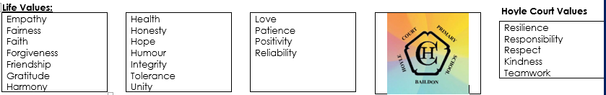

Appendix C – The Behaviour for Learning stories.
Each of our values at Hoyle Court link with a story. This story is used to illustrate to the children an example the Behaviour for Learning value. These can be found below:
The Wolf
Independence
One day Wolf realised that one of his most prized coins was missing. He was a bit worried about how to go about finding it.
So, he decided to ask the ants because he had seen them work well as a team before and felt that they would be the best detectives in the forest! As he travelled to find them he came across Monkey. Monkey asked lots of questions and was excited to try and help. “Lion will help you, Wolf,” the monkey chattered. “He always tries to impress and he’d be proud to solve this problem for you. Find him!”
So, Wolf headed deeper into the forest to find Lion. Before long, he came across Tortoise. She thought carefully about the problem and began to suggest different ways of finding the coins, she felt perhaps the ants could use some help and wanted to draw up a variety of plans to see which would be the best option.
“Well,” thought Wolf, “these all seem like good ideas but what matters to me is that I find my coin and find it quickly!” Wolf appreciated the ideas of the others but he knew what his goal was and didn’t want to get distracted. He thanked the animals politely and focussed on his own strengths. On he travelled.
An eagle began to circle above his head. “Wolf!” cried Eagle, “I have heard you are looking for your coin!” Eagle explained that the ants, Monkey, Lion and Tortoise were proud of Wolf for having a go independently. “Challenge yourself Wolf! You can do it!” he yelled as he swooped away.
Wolf knew he has made the right decision and before long had found his prized coin all by himself!

The Ant
Collaboration
Once upon a time, there was a great famine in which the animals jealously hoarded whatever food they could find, hiding it even from their friends and neighbors. One day, a kindly looking Ant scampered into a village and began asking questions as if he planned to stay for the night.
“There’s not a bite to eat in the whole province,” he was told by the Eagle. “You better keep moving on.”
“Oh, I have everything I need,” he said. “In fact, I was thinking of making some stone soup to share with all of you.” He pulled an iron cauldron from his wagon, filled it with water, and built a fire under it. Then, with great ceremony, he drew an ordinary-looking stone from a velvet bag and dropped it into the water.
By now, hearing the rumour of food, the Tortoise and Wolf and most of the animals had come to the square or watched from their windows. As the Ant sniffed the “broth” and licked his lips in anticipation, hunger began to overcome their skepticism.
“Ahh,” the Ant said to himself rather loudly, “I do like a tasty stone soup. Of course, stone soup with cabbage — that’s hard to beat.”
Soon a Lion approached hesitantly, holding a cabbage he’d retrieved from its hiding place and added it to the pot.
“Wonderful” cried the Ant. “You know, I once had stone soup with cabbage and a bit of salt beef as well, and it was fit for a king.”
The Monkey managed to find some salt beef . . . and so it went, through potatoes, onions, carrots, mushrooms, and so on, until there was indeed a delicious meal for all.
By working collaboratively, with everyone contributing what they can, a greater good is achieved.

The Eagle
Challenge
A wise old owl was looking for an assistant to help with him with his busy jobs. He set a challenge. Every animal who wanted to qualify had to get to the top of the highest mountain in the land, where an ancient castle was located, and return with the magical golden feather. This, thought the owl, will prove who is worthy of working for me.
Many animals from forests near and jungles far came to take on the challenge. But as soon as they started to ascend the mountain, they realised it would be an impossible task.
Tortoise was determined but too small to make the journey alone.
Ant took a team with him and made it the first few metres, but it was a feat too great.
Wolf set off alone but had to turn back.
Would any animal succeed with such a challenge?
Along came Eagle. “I am motivated to do well and I can challenge myself!” she announced confidently.
“It will be hard work,” warned the wise old owl, “Many others have tried and failed.”
“But I like the feeling of being stretched,” Eagle replied. “I will return successful, with the magical golden feather and prove I am worthy of the job!” And off she flew to try.
And try she did. Eagle flew to the summit and entered the ancient castle, found the magical golden feather and clasped it carefully in her claws. She made her descent and headed straight for the wise old owl. Proudly, she presented him with the feather and proved that she had not been afraid of his challenge!
The owl was surprised but thrilled that Eagle had achieved so much and immediately gave her the job of being his assistant.

The Lion
Pride
News had spread that a local company wanted to cut down the forest and build some new properties on the land, to which the animals were shocked, saddened and frightened. The forest was their home!
Monkey asked ‘why?’ and sought to find out what was going on.
Tortoise was resilient and showed his best skill of finding new strategies, but nothing seemed to work.
Eagle worked really hard to change the mind of the company, but nothing seemed to work.
Ant brought together a team to tackle the problem and gained lots of support, but nothing seemed to work.
Wolf listened to everyone’s ideas and watched everyone have ago at finding a solution. It felt impossible! Wolf remembered Lion always represented strength and courage to the other animals. So, now that they were faced with a problem, they knew Lion would be able to help them.
Lion gathered the animals together and explained that together, as a team, they were aiming for a positive ending to such a horrible worry. Lion was keen to impress the other animals with his bravery and so hid his own concerns a little. Lion directed the other animals to write letters explaining how the proposed building works would affect each of their habitats and families and together they would take them to the person in charge. He encouraged, supported and cheered on the animals.
The next day, Lion represented the other animals and took the collection of letters to the person in charge and left them there for her consideration. Together they waited. At last, an owl swooped down with the news they had been waiting for – the forest was saved! The animals celebrated and thanked Lion. Lion felt proud.
“Always aim for the very best outcome,” Lion said, “I feel pleased I have made progress here.”

The Tortoise
Determination
There once was a speedy hare who bragged about how fast he could run. Tired of hearing him boast, Tortoise, who was known for being steady, thorough and keen to do his best, challenged him to a race. All the animals in the forest gathered to watch.
Hare ran down the road for a while and then paused to rest. He looked back at Tortoise and cried out, "How do you expect to win this race when you are walking along at your slow, slow pace?"
Hare stretched himself out alongside the road and fell asleep, thinking, "There is plenty of time to relax, Tortoise is so steady that he will never beat me."
Tortoise walked and walked. He never, ever stopped until he came to the finish line. Tortoise knew that determination would see him right. This behaviour had always helped him succeed in the past.
The animals who were watching cheered so loudly for Tortoise, they woke up Hare!
Hare stretched and yawned and began to run again, but it was too late. Tortoise was over the line.
After that, Hare always reminded himself, "Don't brag about your lightning pace, for being determined won the race!"

The Monkey
Curiosity
The route to the market place was long and tiresome. The animals travelled the pathway every week and every week they complained about how long and tiresome it was. Monkey stopped at the beginning of yet another journey and asked a passing giraffe, “Why do we always go this way? Can we not find another way?”
Giraffe replied, “We always go this way. It is the way we go,” and with that, he walked away, not really giving Monkey’s curiosity any respect.
Monkey went a little further and came across a family of bears. “Bear, aren’t you tired?” Monkey asked.
Bear replied, “We always go this way. It is the way we go,” and with that, he walked away, not really giving Monkey’s curiosity any respect.
Monkey went a little further and came across a crocodile edging his way towards the pathway, fresh from a dip in the lake. “Crocodile!” Monkey called, “Aren’t you tired? The journey is so long.”
Crocodile replied, “We always go this way. It is the way we go,” and with that, she crawled away, not really giving Monkey’s curiosity any respect.
This didn’t bother Monkey too much though, he remembered his friend Tortoise has shown him that determination can get you what you want – so he set off to find another way!
Monkey looked for different pathways and made a connection to a journey that he had taken before – he noticed this was a quicker way to the market place and so had found a shortcut! Monkey decided to share his news with the other animals on the journey. He could show them all the shorter route and together they would have an easier journey to the market place!
Monkey was so pleased he had achieved this, but would he settle with that….? Or would he think ‘what next?’…

